UNIVERSITY OF THE EAST

Rating
152 Samson Road, Caloocan City
College of Engineering
Information Technology Department

CCS2101 – OBJECT ORIENTED PROGRAMMING
Quiz 2

Name | RAMIREZ, ISHMAEL L. | Section: | IT2G
Student Number | 20201132141 | Professor: | Celis, J. R. E.

INSTRUCTIONS:
- For each problem, paste the code and sample output here.
- Make sure your name and student number are printed at the end of the output.

EXAMPLE:

Sample Problem:

Create a program that accepts two numbers, then displays the sum, difference, product, and quotient.

Code: Sample Output:
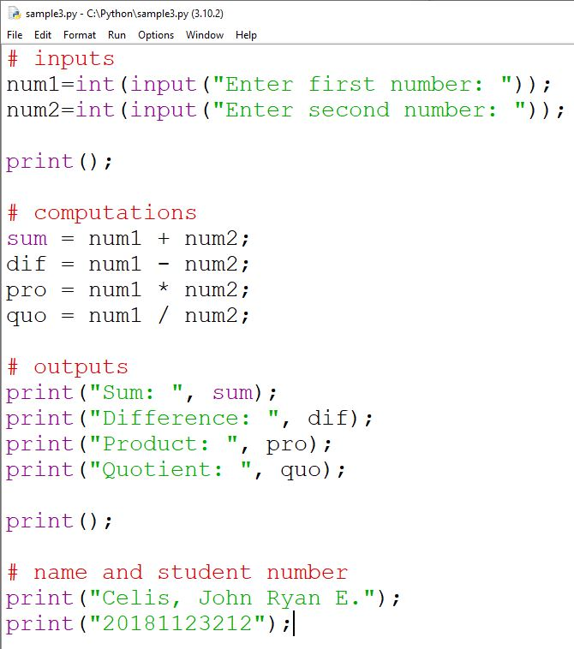
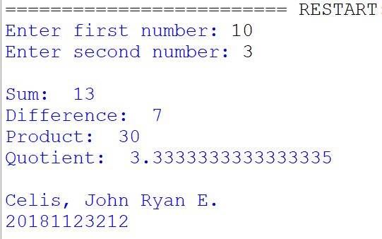

Problem 1:

Create a C++ application that will allow the user to enter any number. The input will only stop if the entered number is 0. The program will then display the following:

- Total numbers entered including 0
- Sum of all the numbers entered
- Average of all the numbers entered
- Total odd numbers entered
- Total even numbers entered including 0
- Total negative numbers entered
- Total positive numbers entered including 0

The program should also ask the user if he wants to try the program again. The program will execute again if the user enters “Y”, and will terminate if the user enters “N”.

Use functions to compute for the necessary values written on the previous bullets.
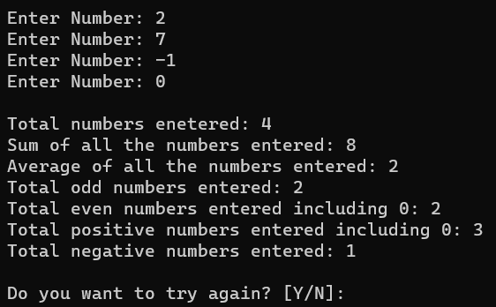
Sample Output:

Code:
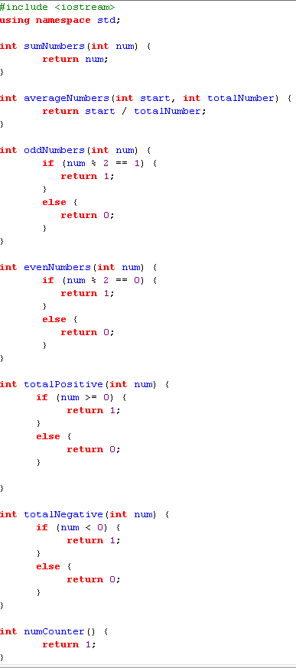
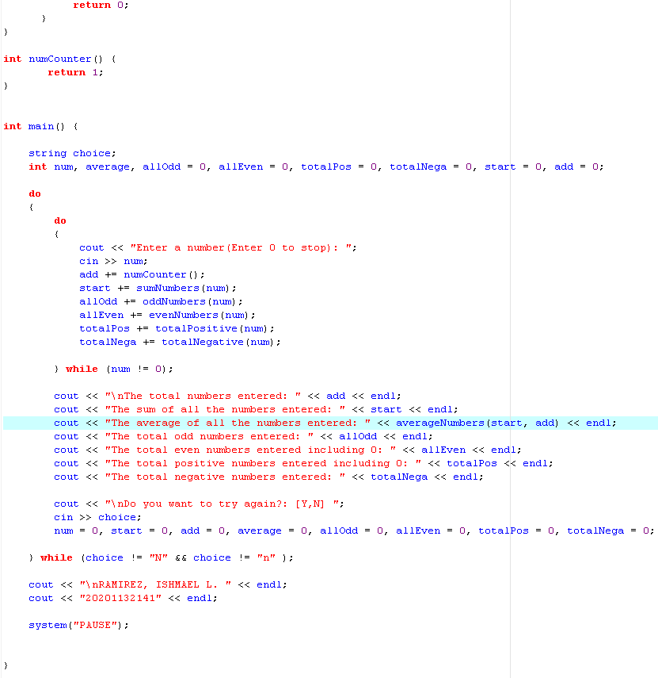

Output:

